Report Transportation

by Aliaksandr Labayeu

# Transportable tablespaces and DB Links:

## Transportable tablespaces

Tablespaces in Oracle can be moved from one DB to another even if it has different block size

1. Creating users & grants with tablespaces

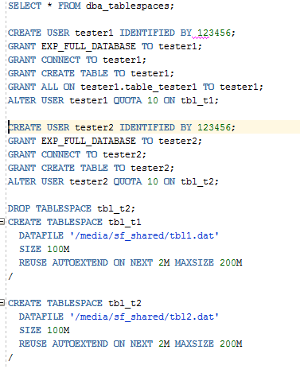

It is important not to forget to make tablespace READ only, so as not to allow it for usage from another USERS. However if its not READable, SQL*Plus sends an error.



Screenshot from SQL*Plus

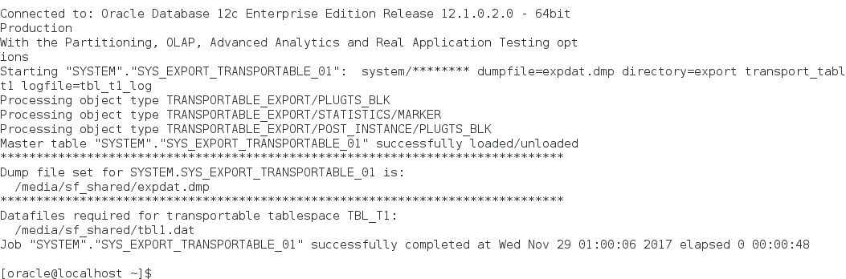

Result of extract:

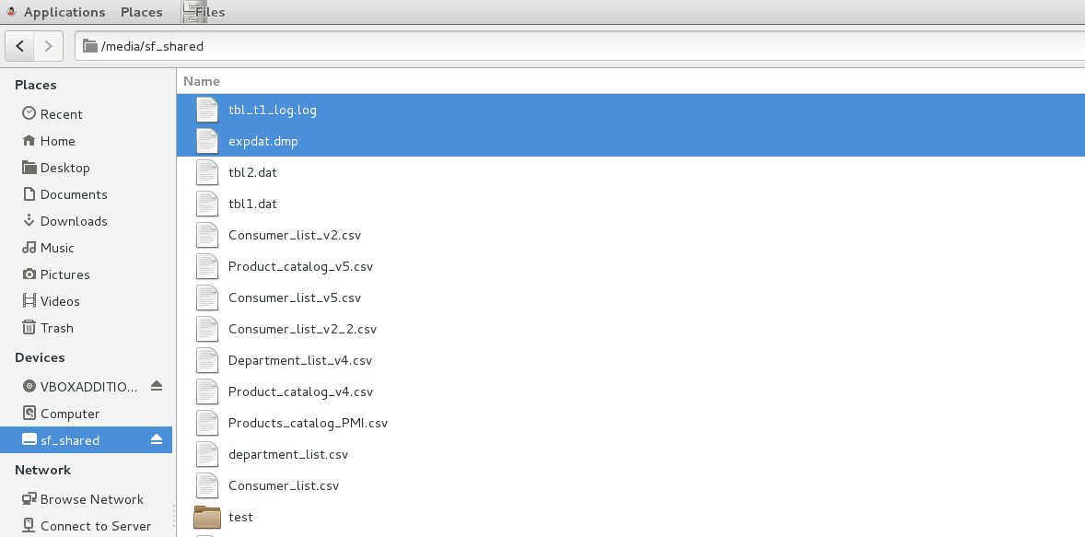

Import is the opposite action that performs with the query:



## DB Links

Adding one more Grant to user ‘teste2’

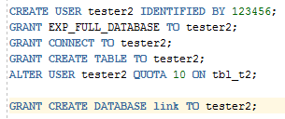

Creating link by new user tester2

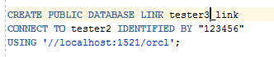

Public links and its execution:

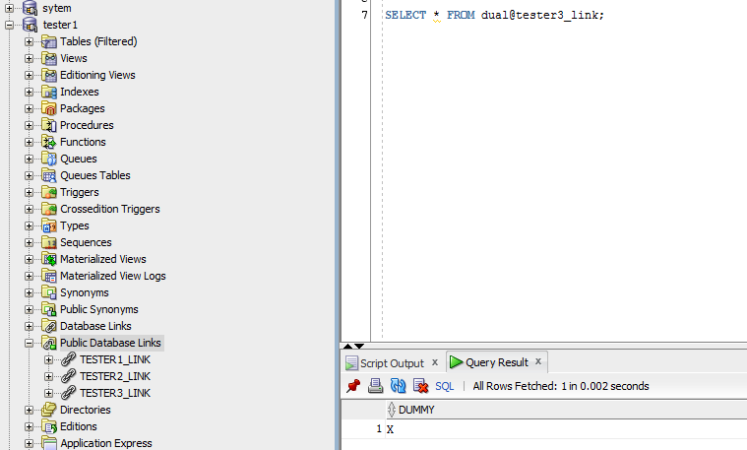

# Table Functions

1. Creating types to support table funcitons

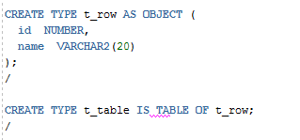

1. Creating function which will be called from table

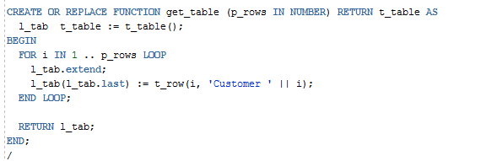

1. Getting results

